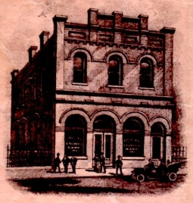
Museum Brick Program Order Form

Historical Society of West Point

Mission: To preserve, interpret, and share the historical significance of West Point and its natural resources to Virginia and the Nation beyond.

A beautiful brick walkway spans the length of the park on the left side of the museum building. Please consider donating a brick in honor of or in memory of your loved one, organization or business. Please note: Political comments, profanity, threats, personal opinions or incendiary comments are not allowed. The HSWP reserves the right to reject any brick order that is considered inappropriate.

Brick Information
- 4-inch x 8-inch Engraved Brick Paver at $250 each.
- Please fill out accordingly. Three lines of text are available with 20 characters on each line per brick.
- Please print clearly and double-check your spelling. Lettering will be in all caps.
- For additional bricks, please attach a separate piece of paper with text information and send one payment.
- Orders will be placed on February 15th and August 15th of each year.
☐ ☐ ☐ ☐ ☐ ☐ ☐ ☐ ☐ ☐ ☐ ☐ ☐ ☐ ☐ ☐ ☐ ☐ ☐ ☐
☐ ☐ ☐ ☐ ☐ ☐ ☐ ☐ ☐ ☐ ☐ ☐ ☐ ☐ ☐ ☐ ☐ ☐ ☐ ☐
☐ ☐ ☐ ☐ ☐ ☐ ☐ ☐ ☐ ☐ ☐ ☐ ☐ ☐ ☐ ☐ ☐ ☐ ☐ ☐

Donor Information (please print or type) Single Brick ☐ Multi Brick ☐

Name

Billing Address

City, ST, Zip Code

Phone 1 | Phone 2

Email
Cash ☐ |  | Amount:
Check ☐ |  | Amount:
Credit Card ☐ |  | Amount:
 |  | Expiration Date:
 |  | MasterCard ☐ Visa ☐ American Express ☐
 |  | Credit Card Number: CSC:
 |  | Card Holder Signature
Signature(s) |  |  |  | Date
THANK YOU FOR YOUR DONATION.  It is tax deductible. We are a 501 (c) 3  non- profit (EIN 26-2758962). |  |  |  | Please make checks payable to:  Historical Society of West Point | P.O. Box 1556  West Point, Virginia 23181

